**CLICKN’STYLE: SOFTWARE-AS-A-SERVICE FOR**

**SALON SHOPS**

A Proposal

presented to the Faculty of the

College of Computer Studies, University of Cebu

In Partial Fulfillment of the Requirements

for the degree Bachelor of Science in Information Technology

By

Mark Vincent C. Cuyos

Kent Wilhelm B. Gabutan

Maria Rhoda A. Ortiz

Jezeryl F. Manatad

Christine T. Glipa

Mr. Bell Campanilla

Adviser

October 2016

# **APPROVAL SHEET**

This Research/Capstone Project Study titled**CLICK N’STYLE: SOFTWARE-AS-A-SERVICE FOR SALON SHOPS** prepared and submitted by Jezeryl F. Manatad, Christine T. Glipa, and Mark Vincent C. Cuyos has been examined and is recommended for approval and acceptance.

RECOMMENDED:

**Bell S. Campanilla, MSIT** **Bell S. Campanilla,MSIT**

Adviser IT Research Coordinator

APPROVED by the Examining Tribunal on **Proposal hearing** with a group verdict of Approved with Revisions on March 21, 2016

**Dr. Melvin M. Niñal**

Chairman

**Sheryl B Satorre, Ph. D** **Engr. Dennis S Durano** **Jean Amora**

Member Member Censor

ACCEPTED and APPROVED in partial fulfillment of the requirements in Bachelor of Science in Information Technology

**Dr. Melvin M. Niñal**

Dean, UC-CCS

Date: ___________________

# **ACKNOWLEDGEMENT**

On the very outset and all throughout of this study, we would like to take this chance to extend our most sincere and deepest heartfelt gratitude towards the people who had helped us in overcoming this endeavor because without their help, encouragement and guidance, we wouldn’t have made it this far.

First of all, we are undeniably indebted to the Almighty God for giving us His guidance, strength and enlightenment to finish this study.

We would like to take this opportunity to express our profound gratitude to our adviser and mentor Mr. Bell Campanilla for his exemplary guidance, constant encouragement and for sharing his precious time to us all throughout the duration of this project. His valuable suggestions were of immense help throughout our project work.

To our Dean, Dr. Melvin Niñal, and the UC-CCS Department for giving us the opportunities to work on this encouraging study.

To Ms. Jean Amora who had helped us mold and shape the best output that we could deliver.

To us researchers, Jezeryl F. Manatad, Christine T. Glipa, and Mark Vincent C. Cuyos

for working together as a team in creating this study.

We also acknowledge with a deep sense of reverence, our heartfelt gratitude towards our parents and members of our family, who has always supported us morally as well as economically.

And last but not the least, our thanks goes to all of our friends and fellow students who directly and indirectly helped us to complete this project.

# **DEDICATION**

This Research Paper is lovingly dedicated to our respective parents who have been our constant source of inspiration. They have given us the drive and discipline to tackle any task with enthusiasm and determination. Without their love and support this project would not have been made possible.

**Table of Contents**

**APPROVAL SHEET** ii

**ACKNOWLEDGEMENT** iii

**DEDICATION** iv

**List of Figures** vii

**List of Tables** viii

**Chapter 1** 9

**INTRODUCTION** 9

**Rationale of the Study** 9

**Objectives of the Study** 10

**Scope and Limitation of the Study** 11

**Significance of the Study** 12

**Flow of the Study** 12

**Definition of Terms** 13

**Chapter II** 14

**REVIEW OF RELATED LITERATURE AND STUDIES** 14

**Related Literatures** 14

**Related Studies** 14

**Chapter III** 19

**RESEARCH METHODOLOGY** 19

**Software Engineering Methodology** 19

**Business Model Canvas** 20

**Program Workflow** 21

**Validation Board (Stages 1, 2)** 22

**Gantt chart / Pert Chart** 24

**Functional Decomposition Diagram** 25

**Use Case Diagram** 26

**Story Board (Partial)** 31

**Entity Relationship Diagram** 42

**Data Dictionary** 43

**Network Design** 48

**Network Model** 49

**Network Topology** 49

**Technology Stack Diagram** 50

**Software Specification** 50

**Hardware Specification** 51

**Program Specification** 51

**List of Modules** 51

**References** 59

**CURRICULUM VITAE** 60

**Appendices** 63

Appendix A: Oath of Confirmation Form 63

Appendix B: Capstone Project Team Composition Form 64

Appendix E: Capstone Project Working Title Form 64

Appendix G: Consultation Logs Form 65

Appendix H: Censor/ Technical Editor’s Certificate Form 66

Appendix L: Capstone Project Hearing 66

Appendix M: Capstone Project Panel Honoraria 67

# **List of Figures**

Figure 1: **Flow of the Study** 12

Figure 2: **saloniris.com Homepage** 15

Figure 3: **zenoti.com Homepage** 15

Figure 4: **salonlite.com Homepage** 16

Figure 5: **simplesalon.com Homepage** 17

Figure 6: **Scrum Development Model** 19

Figure 7: **Business Model Canvass** 20

Figure 8: **Web: Program Workflow** 21

Figure 9: **Mobile: Program Workflow** 21

Figure 10: **Functional Decomposition Diagram** 25

Figure 11: **Use Case Diagram: Super Admin** 26

Figure 12: **Use Case Diagram: Owner** 26

Figure 13: **Use Case Diagram: Salon Admin** 27

Figure 14: **Use Case Diagram: Manage Personnel** 27

Figure 15: **Use Case Diagram: Manage Services** 28

Figure 16: **Use Case Diagram: Manage Promos** 28

Figure 17: **Use Case Diagram: User – Web** 29

Figure 18: **Use Case Diagram: User – Mobile** 30

Figure 19: **Story Board -Web –Home** 31

Figure 20: **Story Board - Select User Type** 31

Figure 21: **Story Board - User Registration** 31

Figure 22: **Story Board - Client Registration** 32

Figure 23: **Story Board - Home Page (User)** 32

Figure 24: **Story Board - Reservation Page** 32

Figure 25: **Story Board - Reservation Calendar** 33

Figure 26: **Story Board - Reservation Details** 33

Figure 27: **Story Board - Reservation Payment** 33

Figure 28: **Story Board - Personnel** 34

Figure 29: **Story Board - Services** 34

Figure 30: **Story Board - Services (Salon)** 34

Figure 31: **Story Board - Services (Service)** 35

Figure 32: **Story Board - Home (Salon Admin)** 35

Figure 33: **Story Board - Reservation (Calendar)** 35

Figure 34: **Story Board: Reservations** 36

Figure 35: **Story Board: View Personnel** 36

Figure 36: **Story Board: Add Personnel** 36

Figure 37: **Story Board: Services** 37

Figure 38: **Story Board: Establishment (Super Admin)** 37

Figure 39: **Story Board: Log in – Mobile** 37

Figure 40: **Story Board: Registration - Mobile** 38

Figure 41: **Story Board: Home – Mobile** 38

Figure 42: **Story Board: Reminder – Mobile** 39

Figure 43: **Story Board: Location - Mobile** 39

Figure 44: **Story Board: Reservation – Mobile** 40

Figure 45: **Story Board: Services - Mobile** 41

Figure 46: **Story Board: Promos - Mobile** 41

Figure 47: **Story Board: Search personnel – Mobile** 42

Figure 48: **Entity Relationship Diagram** 42

Figure 49: **Network Topology** 49

Figure 50: **Technology Stack Diagram** 50

# **List of Tables**

Table 1 COMPETITOR’S ANALYSIS: OVERVIEW 17

Table 2 COMPETITOR’S ANALYSIS: OVERVIEW CONTINUATION 18

Table 3 COMPARATIVE MATRIX CHECKLIST 18

Table 4 VALIDATION BOARD STAGE 1 22

Table 5 VALIDATION BOARD STAGES 2 23

Table 6 GANTT CHART / PERT CHART 24

Table 7 PAYMENTS 43

Table 8 SALONS 43

Table 9 PAYMENTSUBS 44

Table 10 SUBSCRIPTIONS 44

Table 11 STAFF_USERS 44

Table 12 PROMOS 45

Table 13 TRANSACTIONS 45

Table 14 CUSTOMERS 46

Table 15 PERSONNELS 46

Table 16 POSITIONS 47

Table 17 SALON_SERVICES 47

Table 18 MASTER_SERVICE 48

Table 19 RESERVATION 48

Table 20 SOFTWARE SPECIFICATION 50

Table 21 HARDWARE SPECIFICATION 51

Table 22 LIST OF WEB MODULES 51

Table 23 LIST OF WEB MODULES CONTINUATION 54

Table 24 LIST OF MOBILE MODULES 55

Table 25 LIST OF MOBILE MODULES CONTINUATION 57

Table 26 LIST OF MOBILE MODULES CONTINUATION 57

# **Chapter 1**

## **INTRODUCTION**

### **Rationale of the Study**

Beauty is one of the most common factors that set humans apart. Physical appearance is one of the major components that matter to most, especially during job application and interviews. Everyone has their own mind set on how to face daily lives; with a great physical appearance and a stunning look to deal with people. Each wants to look presentable, every human being wants to look good, feel good about themselves. Being beautiful is a factor that every human being would want. Traditionally, women are considered the ones who give too much importance in this matter.

One of the most important element of owning a successful and portable business is creating a suitable and smooth flow of services for customers. Generally people are well-known as business enthusiasts. They come up with solutions that help people’s task become easier. One of the most common problem is getting into salon shops. Salon shops is one of the most in demand businesses of today.

With the growing population and the modernization of the environment, people also look for things that maintain their demands and maintain the natural high class environment. It’s never too soon to start thinking about some of the operational issues that will impact and contribute to the success of a business. Some people are deprived of their privileges to enjoy the quality of good customer service.

Technology plays an important role in the salon business. The applications are accessible from various client devices through web browsers and mobile-based application. Where websites allow subscriptions and the mobile-based application can be downloaded in google store with the access of the internet. Software-as-a-Service (SaaS) is the delivery of software applications over the internet while being managed by the service provider. Technology affects the competition of business, in addition to serving the clients better, the effective use of technology may increase efficiency and financial institutions to reduce costs.

Like any business, the salon business sector owners also experience problems in dealing on how to maintain and get more customers. Customers consume much time in searching for a beauty salon that offers promos. Clients are searching for a better way to find or look for business that caters beautification.

With the above mentioned problems, the proponents come up with a solution by proposing Click N’Style: A Software as a Service for salon shops. A software where salon shops could subscribe, advertise and allow customers to locate salon shops and view their services.

### **Objectives of the Study**

The primary objective of the study is to design and develop a web and mobile-based software as a service for salon establishments and salon enthusiasts’ online reservation:

Specifically, it aims to:

1. Develop a web application that would manage:

* subscription,
* client profile,
* staff,
* notification,
* reservation,
* user profile
* reports

1. Develop an android application that would manage:

* user profile,
* client profile,
* staff,
* notification,
* reservation,
* user reminder,
* Geo-mapping

### **Scope and Limitation of the Study**

Click N’Style: A Software as a Service for Salon Shops in the locality of Cebu City. Basically, the purpose of the study caters to Hair style salon, Nail style salon, Beauty salon (Hair and Make-up style, Foot Spa) and spa/ massage parlor to locate and to do reservations.

Click N’Style is a web and mobile based application that is designed to benefit both salon establishments and userswhere the establishment owners can manage, announce and post promos to their web portal. The users and salon admin will use Click N’Style through their computers with browsers such as Mozilla Firefox, Opera, or/and Google Chrome. Users can also access through mobile where they can manage their personal profile, view or search for the nearest salon establishments within his/her perimeter through Global Positioning System (GPS), can do reservation to a particular salon establishment and the chosen establishment can send them a confirmation, allows to search for a specific offer depending on their budget. Users can also manage or set a personal reminder. Mobile access can be downloaded using smartphones with the Android operating system (Android 2.2 and up to the latest version). It must be done with the internet connection or Wi-Fi to be able to download and use the application.

In order for the system to use and manipulate its features or/and functions, users must first register before using the application and must agree to the terms, agreements and conditions of every transaction being done. The client must subscribe to the system in order to access the system. User/customers are not allowed to choose a staff in availing for promo services. Users/ customers can only view salon promos, salon promos are only available for walk in customers of salons. Salon establishments must have their PayPal accounts while users must have an account if they want to reserve. All transactions from users to establishments can be done in the web and mobile application. Managing salon establishments, staffs profile, and salon promos can be done only in the web application by the salon admins. The personnel can’t access to the mobile application. The subscription of the establishments allows one salon branch only. Default salon reservation hours are 8am to 5pm for every salon. Reserved time is the actual time that user should be in the salon vicinity for the reserved salon service. System app does not display products of registered salons. The system does not integrate unto social media websites.

Only the administrator has the privilege to deactivate a subscriber’s account if the term of the contract is not renewed. The system is not responsible for any inventory that the salon establishment has; mostly focuses on the user experience only. It is not liable for any profit gain.

### **Significance of the Study**

The purpose of the study will be able to give good feedbacks to a salon establishments. With the participation of the users, researchers and future researchers.

Salon Establishments: The study will help the management of the establishment to record all the reservations of the customers. It will provide an improvement on their service, reservation management system and their announcements and promotions.

Users: The study will help the users to easily locate a salon, to make an online reservation of a particular salon establishments within Cebu city, manage budget and creates self-reminder for their beauty activities.

Researchers: This will give them helpful insights in systems development. It will allow them to utilize what they have cultivated from their school rooms and from their laboratory discussions and also this can help them to be more research-oriented.

Future researchers: This project can serve as reference to other researchers who also handles the same study. It also motivates researchers to redesign, improve and to add more features in this project

### **Flow of the Study**

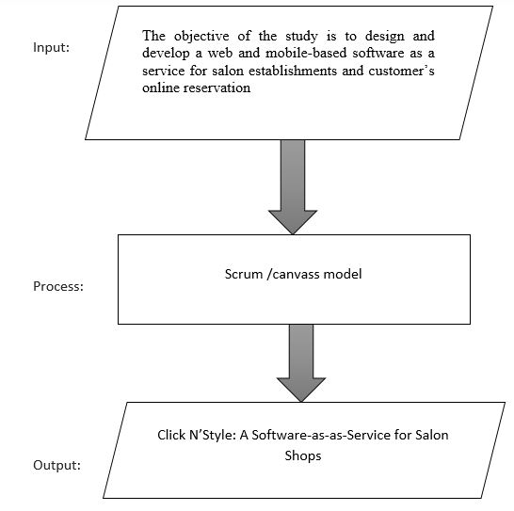

Figure 1:**Flow of the Study**

### **Definition of Terms**

**Click N’Style-** this refers Software-as-as Service for Salon Shops.

**Clients-** the one that subscribes/salon establishments.

**Owner/Salon Admin-** is a person who manages the salon establishment promos, staffs profile, and salon establishment profile/salon establishment admin.

**Promos –** via advertising and/or a discounted price - of a particular product or service

**Portal-** Refers to a website on the internet that provides information for businesses in a particular industry and links to other websites that provide products and services.

**Services-** services that the salon offers.

**Personnel-** is a person who works at salon shop namely: Beautician, Hairdresser or Hairstylist, Nail stylist.

**Staff User Accounts –** it is a user account used by the Staff to have the privileged to use the system and be the salon admin given by the owner to access or use the system.

**Super Admin-**is a person who manages the whole system

**Users-** refers to anyone who uses the system/salon enthusiasts/customers.

# **Chapter II**

## **REVIEW OF RELATED LITERATURE AND STUDIES**

### **Related Literatures**

“You are a GODDESS when you leave the salon” – (Lewis, 2003)

Choosing a location for your salon is one of those important decisions you’ll make in the early stages of establishing your new business. Obviously, you’ll want to locate it in an area that’s easily accessible by highway or byway, with plenty of traffic (both foot and the four-wheeled variety) and parking. The surrounding area should be attractive, well-lit, and safe. There should also be other retail businesses nearby (as opposed to parks or a regional airport) because they can generate business for you as they attract customers through their own doorsthat one of the first things that the customer to be consider is the location of the salons. He added that the trendiness of neighborhood has a big impact on the kind of salons around. A hair salon in a fashionable area is more likely to give you a fashionable hairstyle- one that's very “now.” That may be what you're after, which is great, but beware too that it's often the case that a busy, fashionable hair salon- because they're so busy and fashionable- may have to sacrifice the amount of personal attention provided to clients. They may also charge you more money simply because of the rent of their neighborhood(Roger, 2014).

According to (Prosser, 2015), online booking creates time for staff to have longer conversations with clients that call in by phone. Instead of dealing with the logistics of scheduling, salon staff will have more time (and less interruptions) when talking to new clients that want to learn about the salon, or existing clients that need help figuring out what services they want to book.

“Whoever said money can’t buy happinesshasn’t found the right beauty salon” **–**(Anonymous, 2010)

### **Related Studies**

Some people struggleto finda salon that fits with their budget especially those who are not really into it. Salon owners also find it difficult to maintain, get customers and to advertise the shop. People want information as fast and as easy as possible, that is why they look the help in the internet.

For this reason, salons have web application in the internet nowadays for an easy way of finding a salon. And, the proponents have chosen some significant related studies. These are the following:

**Salon iris**

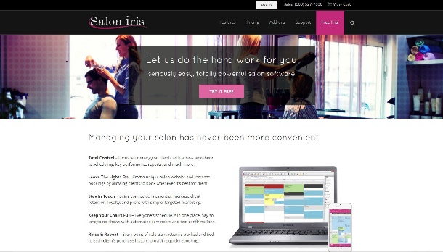

Figure 2:**saloniris.com Homepage**

Incorporated in 1999, DaySmart Software has become nationally recognized as the leading automated business software program, with successful sales across many professional categories such as salons, day spas, medical spas, pet grooming and many other entrepreneurial business categories. Based in Wixom, Michigan, DaySmart Software consists of several different software system programs that target specific businesses. Salon Iris started as the company’s leading software product, and continues to be the most popular software of the suite of products.

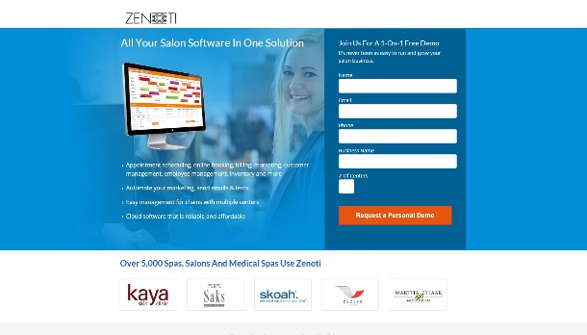**Zenoti**

Figure 3:**zenoti.com Homepage**

Zenoti is a world class organization committed to provide excellent customer satisfaction through efficient services. Zenoti is a leading cloud-based, business software used by spas, salons and medi-spas. With Zenoti is all-in-one solution, spa and salon mangers are more easily able to manage all aspects of their business from managing their appointment book, billing through a POS, CRM, employee schedules and payroll,  inventory, running marketing promotions, enabling online booking and online sales and more.

**Salonlite**

Salonlite is a fully optimized cloud solution built with the latest technologies that provides a robust and secure scheduling solution for salons and spas around the world. Salonlite is a quick and easy solution that can be set up and fully functional within a few minutes.

All aspects of the system are monitored and can be reported upon from a series of easy to run reports and an elegantly consolidated dashboard. With the built in functionality, the clients will be reminded via text messages or E-mails.

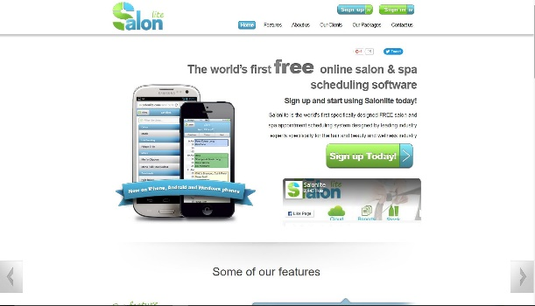

Figure 4:**salonlite.com Homepage**

**Simple Salon**

Simple Salon operates as an online web portal for salon business. Simple Salon is present in over 4 countries. It was founded in 2005.

Simple Salon is the simplest way to enhance your hair or beauty salon. It helps you manage your appointments, record client details and keep an eye on the performance of your business. It’s extremely easy to setup and to start right away.

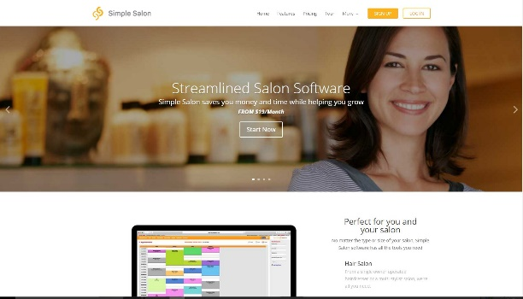

Figure 5:**simplesalon.com Homepage**

#### **Comparative Matrix**

Table 1

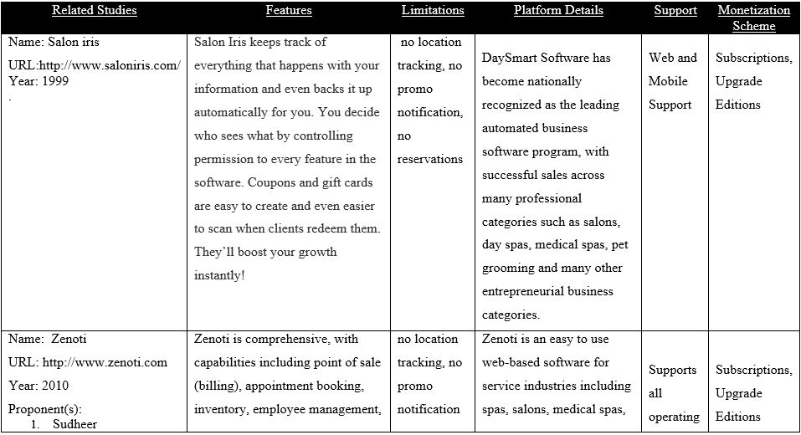COMPETITOR’SANALYSIS:OVERVIEW

Table 2

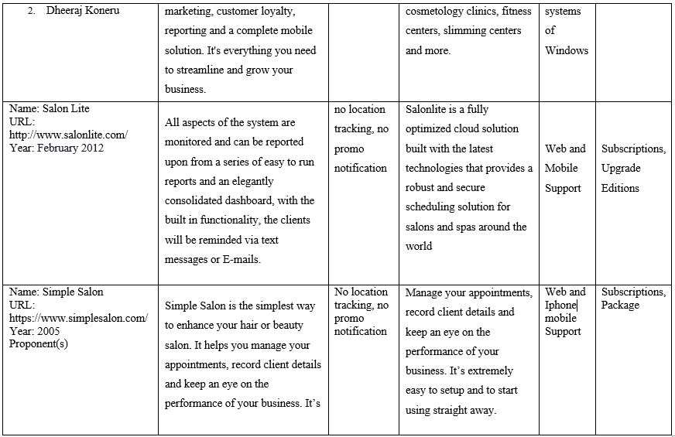COMPETITOR’SANALYSIS: OVERVIEWCONTINUATION



Table 3

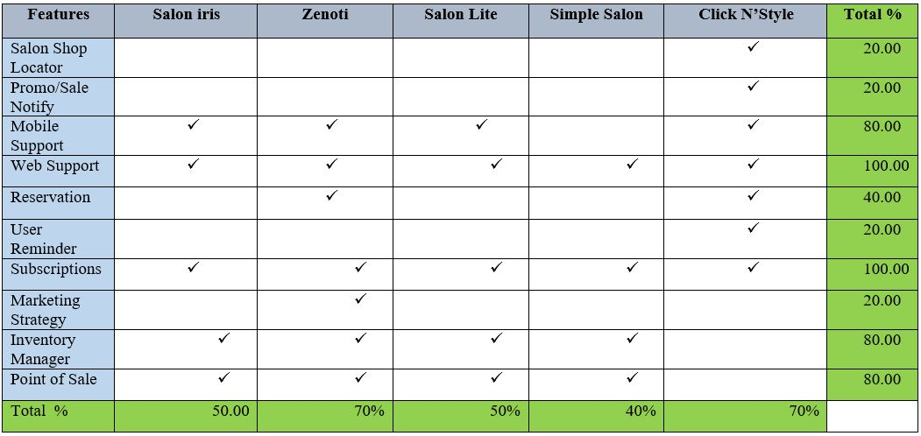COMPARATIVEMATRIXCHECKLIST

A Comparative Matrix is usedto evaluate the different features of the study to compare and to calculate the percentage according to the number of features offered by the competitors.

# **Chapter III**

## **RESEARCH METHODOLOGY**

### **Software Engineering Methodology**

Scrum is a subset of Agile. It is a lightweight process framework for Agile development.It is a set of principles for software development in which requirements and solutions evolve through collaboration between self-organizing, cross-functional teams. Scrum is most often used to manage complex software and product development, using iterative and incremental practices. Scrum significantly increases productivity and to reduce the time. Scrum processes enable organizations to adjust smoothly to rapidly-changing requirements, and produce a product that meets evolving business goals(CPprime, 2010).

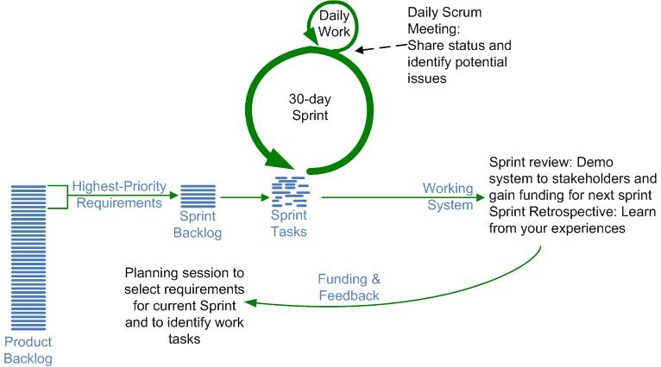.

Figure 6: **Scrum Development Model**

With Scrum, the Product Owners provide requirements, in the form of Stories or backlogs, then the team implements the stories in the period of 2-4 weeks. During the Sprint, Team members work with Product Owners to refine and clarify requirements, to ensure proper implementation. Final requirements are defined by test cases by QA Engineers/Analyst and are used to validate each story to confirm that it is complete. After it is complete, the team will review, reflect all that was done and will repeat if it is necessary(Pedia, 2011). Like any other agile methodology, this is also iterative in nature. It requires continuous feedback from the user. Due to short sprints and constant feedback, it becomes easier to cope with the changes.

### **Business Model Canvas**

The Business Model Canvas is a strategic management and lean startup template for developing new or documenting existing business models. It is a visual chart with elements describing a firms or product's value proposition, infrastructure, customers, and finances. It assists firms in aligning their activities by illustrating potential trade-offs(Wikipedia)

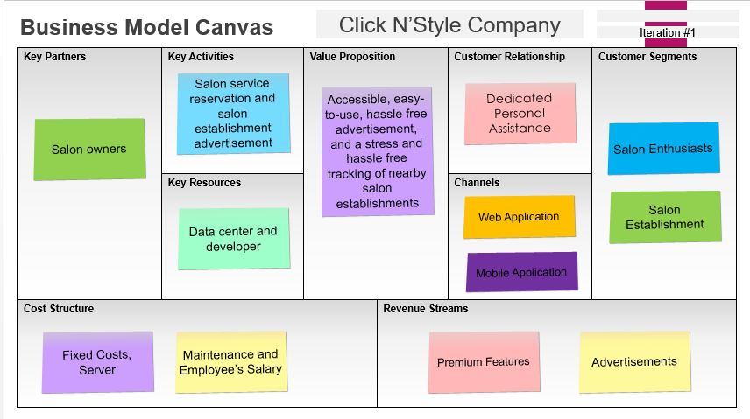This is a model that uses to define the components of business. It offers an interactive way to look at thebusiness model and improve the results. It's a way to keep moving forward with an iterative business plan.

Figure 7: **Business Model Canvass**

### E:\Capstone41.2\Program Workflow\qweqweq.JPG**Program Workflow**

Figure 8: **Web: Program Workflow**

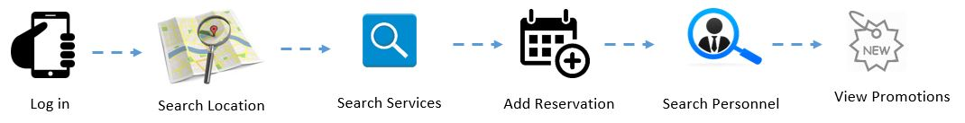

Figure 9: **Mobile: Program Workflow**

### **Validation Board (Stages 1, 2)**

Table 4

VALIDATION BOARD STAGE 1

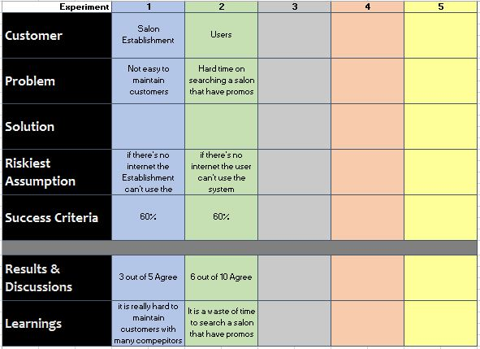

Table 5

VALIDATION BOARD STAGES 2

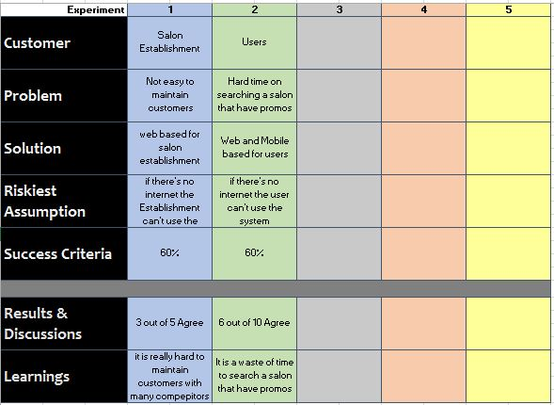

### **Gantt chart / Pert Chart**

Table 6

GANTTCHART / PERTCHART

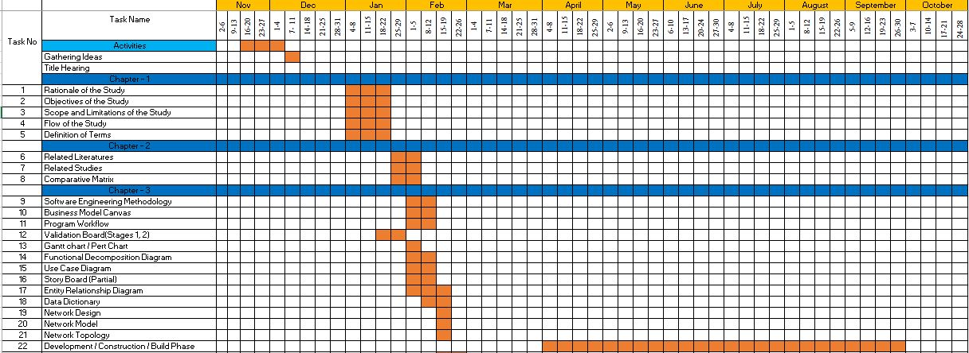



### **Functional Decomposition Diagram**

The Functional Decomposition Diagram (FDD) is a business planning tool that depicts the hierarchy of business functions, processes, and subprocesses within an organization. It shows a hierarchical organization of the functions that comprise the system operations. Functional decomposition is most commonly used during the analysis phase of a project to produce functional decomposition diagrams as part of the functional requirements document. It can also be used during the planning, analysis and design phases of a project to help clarify business operations.

The process of FDD explains the breakdown of processes within the project or business area. This is to break a complex problem into layers of more manageable and comprehensive pieces, resulting in a hierarchically structured that describes the problem and/or solution in levels of details.

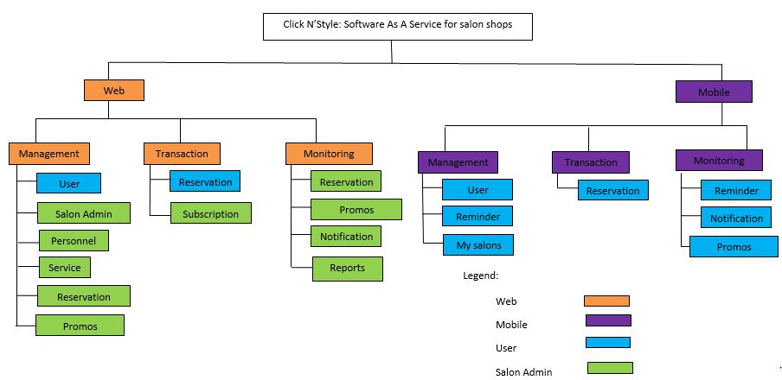

Figure 10: **Functional Decomposition Diagram**

### **Use Case Diagram**

A use case is a formal way of representing how a business system interacts with its environment. A use case illustrates the activities that are performed by the users of the (Whitten, 2004).

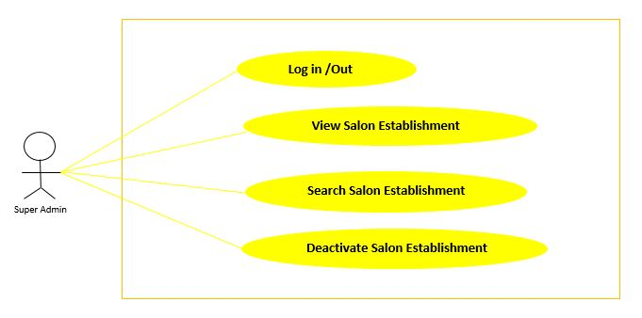

Figure 11: **Use Case Diagram: Super Admin**

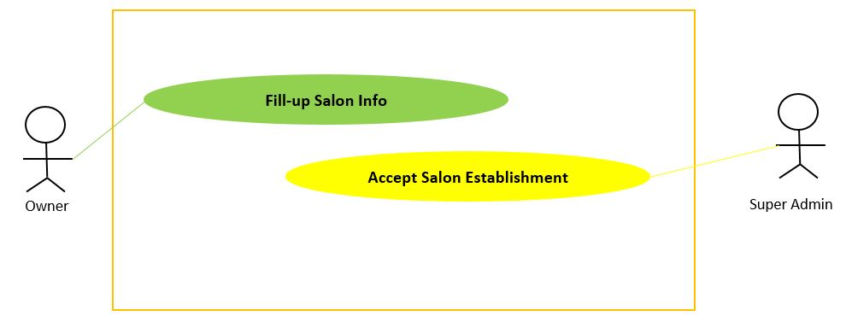

Figure 12: **Use Case Diagram: Owner**

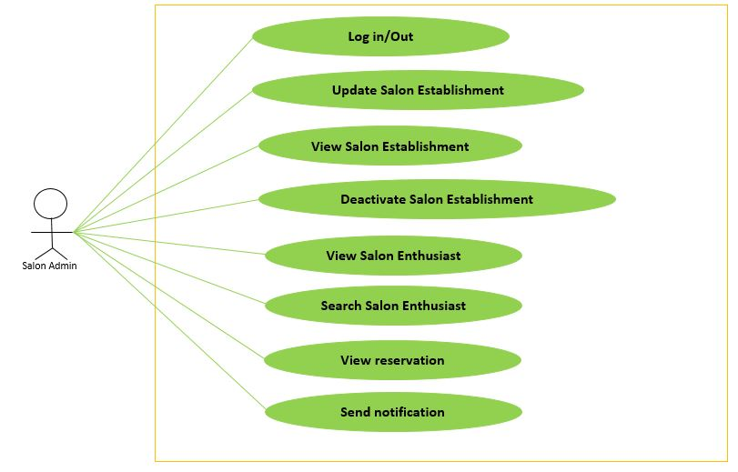

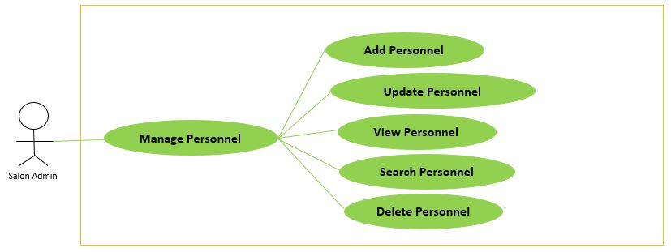Figure 13: **Use Case Diagram: Salon Admin**

Figure 14: **Use Case Diagram: Manage Personnel**

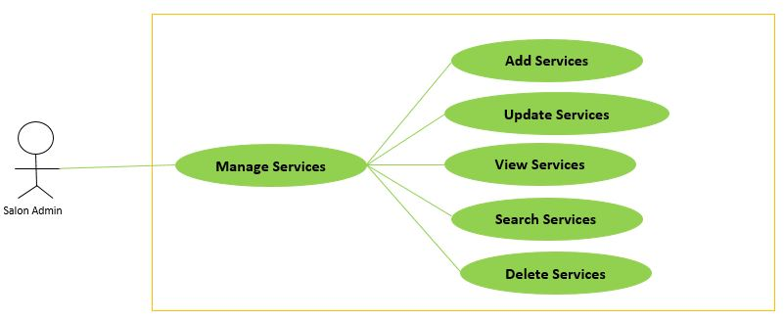

Figure 15: **Use Case Diagram: Manage Services**

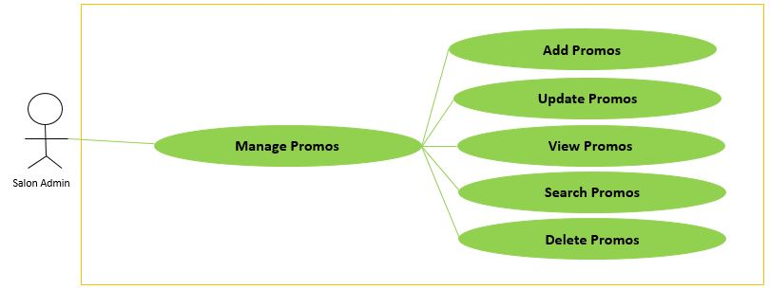

Figure 16: **Use Case Diagram: Manage Promos**

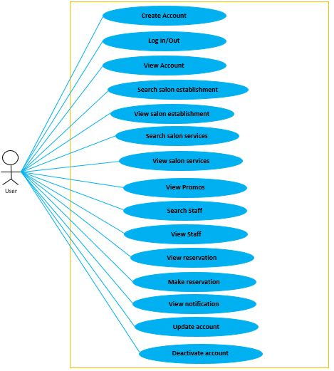

Figure 17: **Use Case Diagram: User – Web**

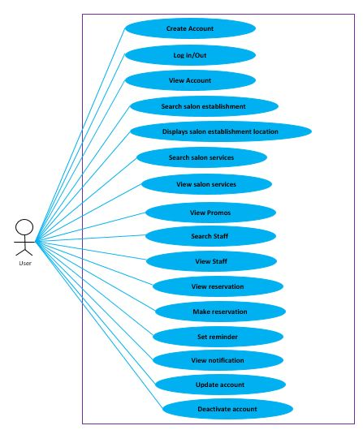

Figure 18: **Use Case Diagram: User – Mobile**

### **Story Board (Partial)**

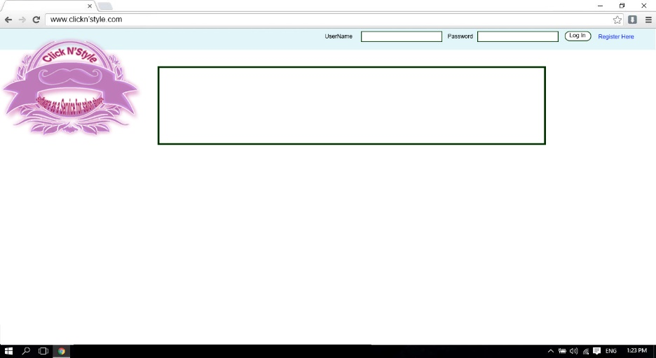

Figure 19: **Story Board -Web –Home**

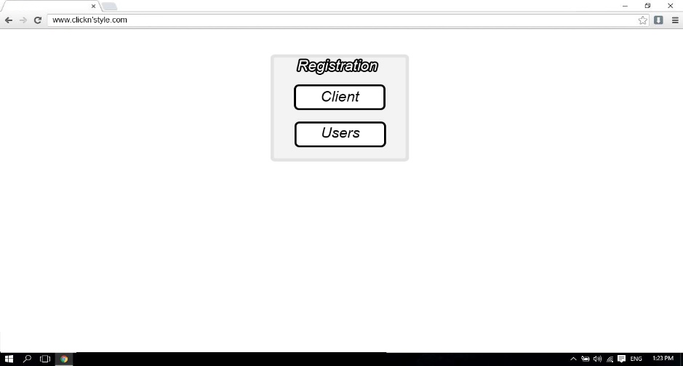This is the first page for those who want to visit the website.

Figure 20: **Story Board - Select User Type**

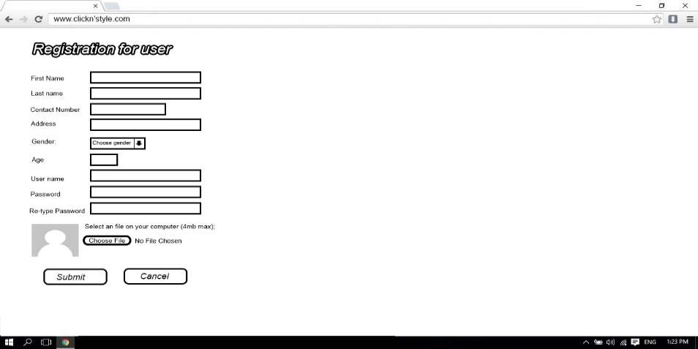The user will select if he is auser or anowner before register.

Figure 21: **Story Board - User Registration**

The user will fill up the form for registration.

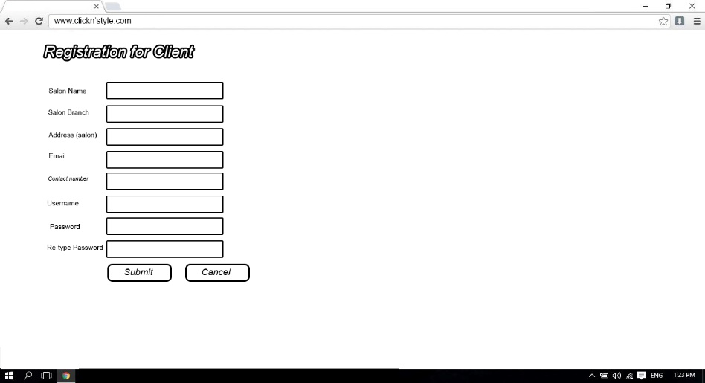

Figure 22: **Story Board - Client Registration**

The owner will fill up the form so that they can subscribe in the system.

#### **User Story Board**

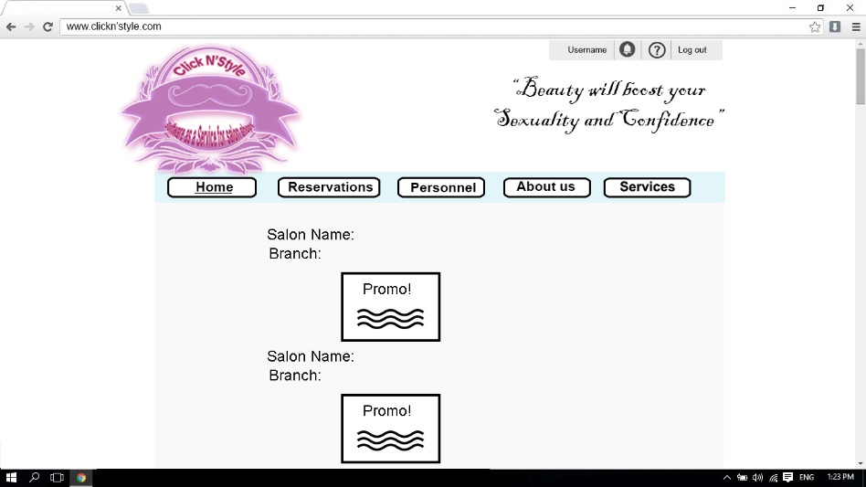

Figure 23: **Story Board - Home Page (User)**

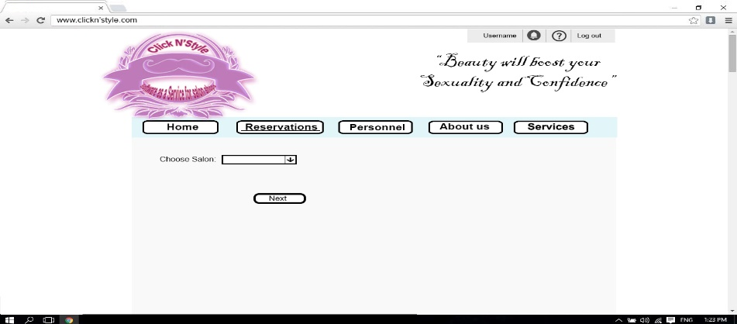This is where a user will see the promos of each salon branch that subscribed system.

Figure 24: **Story Board - Reservation Page**

This is where the user will choose a salon to reserve.

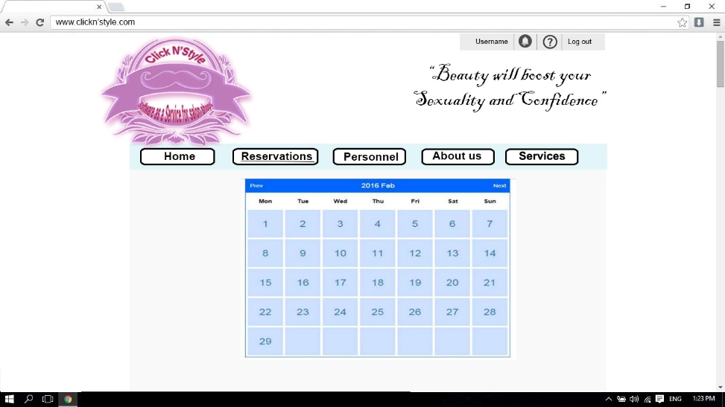

Figure 25: **Story Board - Reservation Calendar**

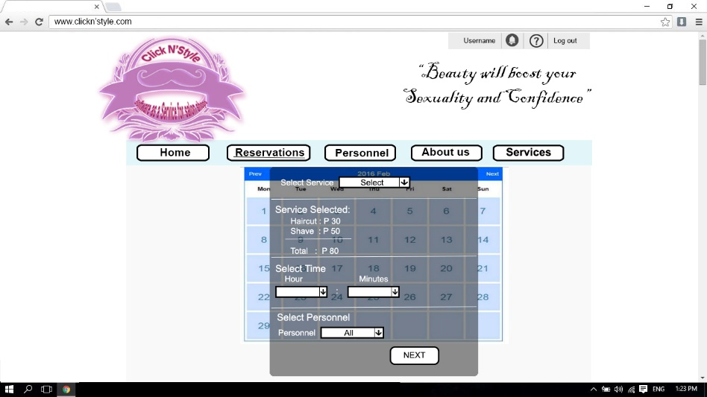This is where the user will choose a date that he wants to reserve.

Figure 26: **Story Board - Reservation Details**

The user will choose what kind of service and what time they want.

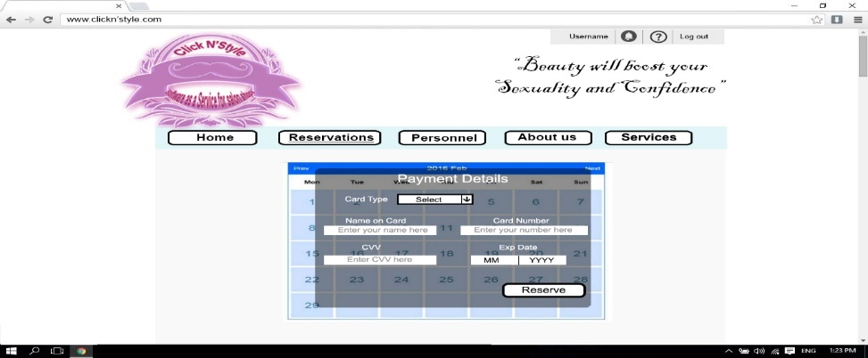

Figure 27: **Story Board - Reservation Payment**

The user must pay online in order to make a reservation.

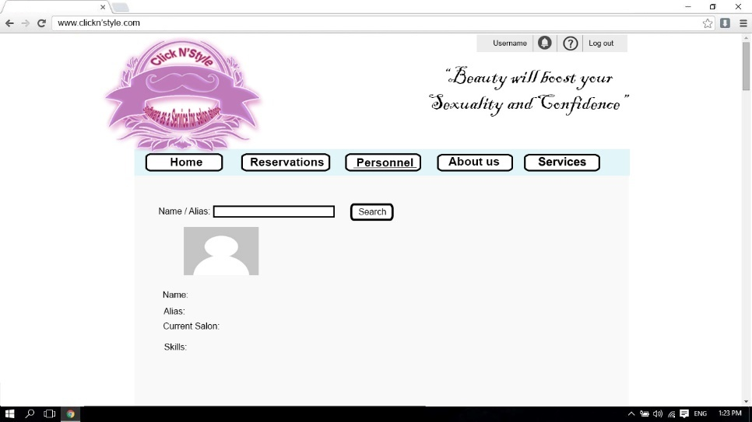

Figure 28: **Story Board - Personnel**

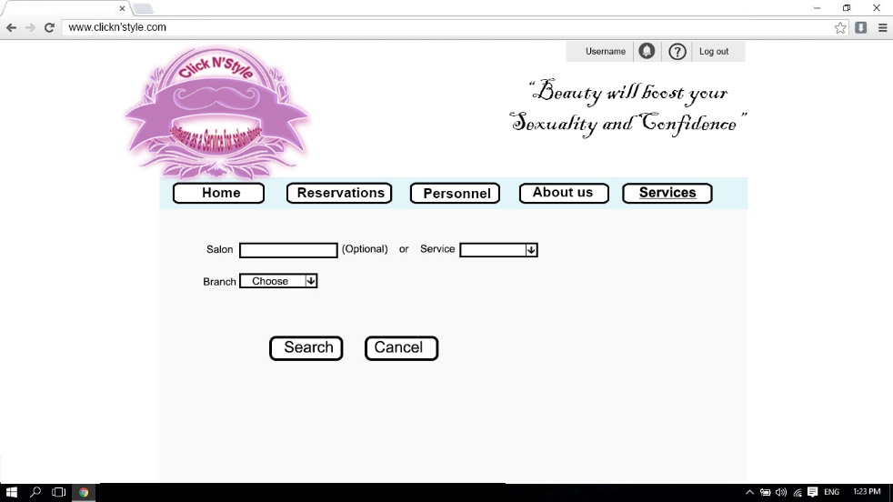A user can search a certain personnel.

Figure 29: **Story Board - Services**

The user will choose either salon or certain service to search.

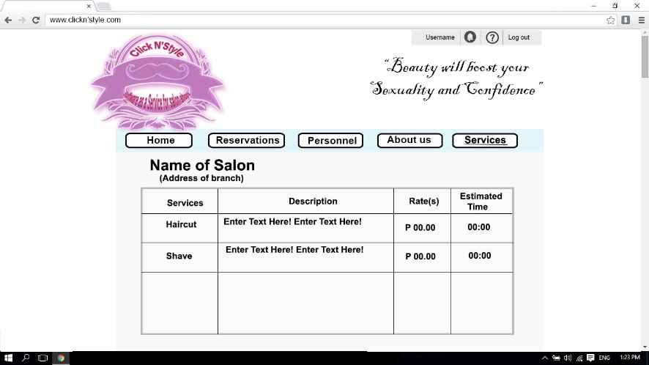

Figure 30: **Story Board - Services (Salon)**

If the user choosesa salon.

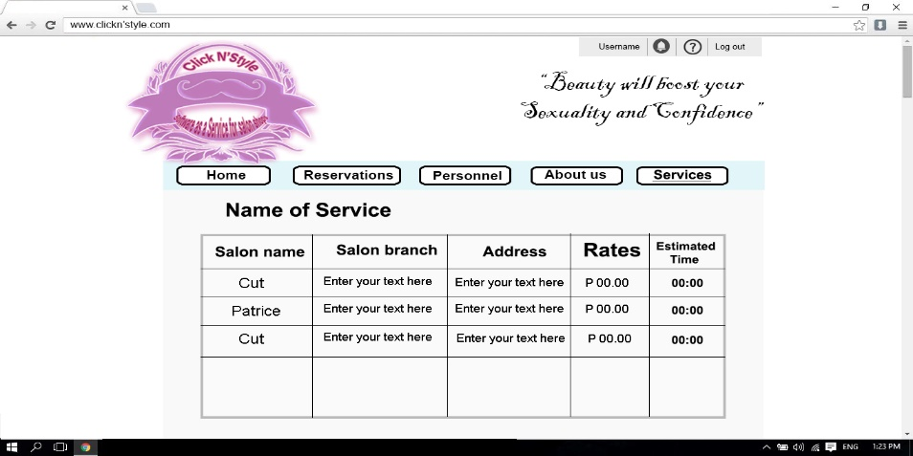

Figure 31: **Story Board - Services (Service)**

If the user chooses a certain service.

#### **Salon Admin Story Board**

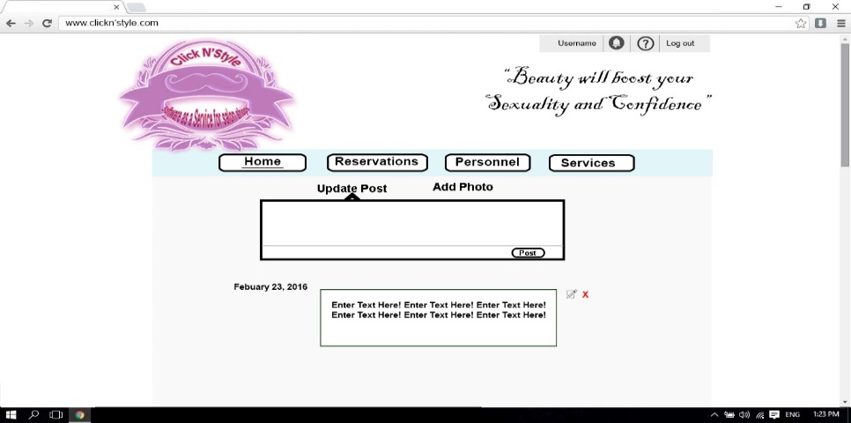

Figure 32: **Story Board - Home (Salon Admin)**

Salon admin will post their promos in their home page.

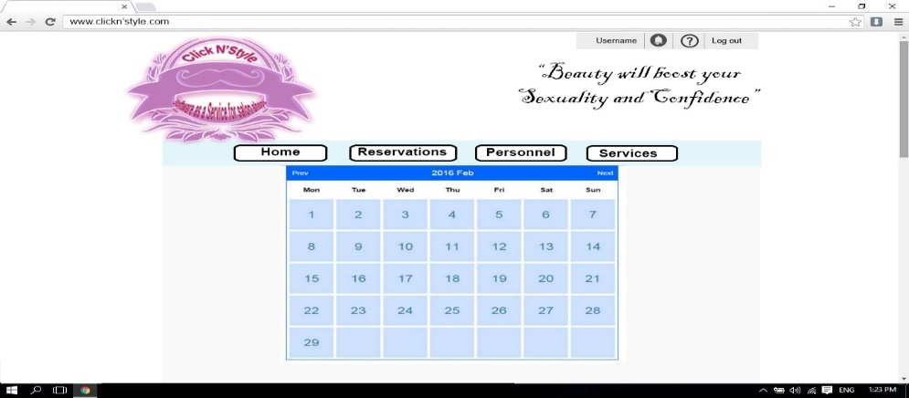

Figure 33: **Story Board - Reservation (Calendar)**

Salonadmin willreceive notification from the customers who did reservations.

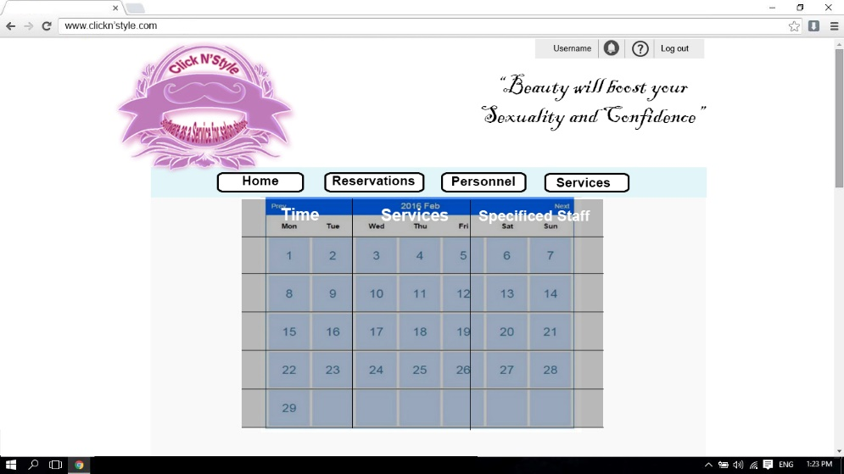

Figure 34: **Story Board: Reservations**

Salonadmin will view all those who have reservations.

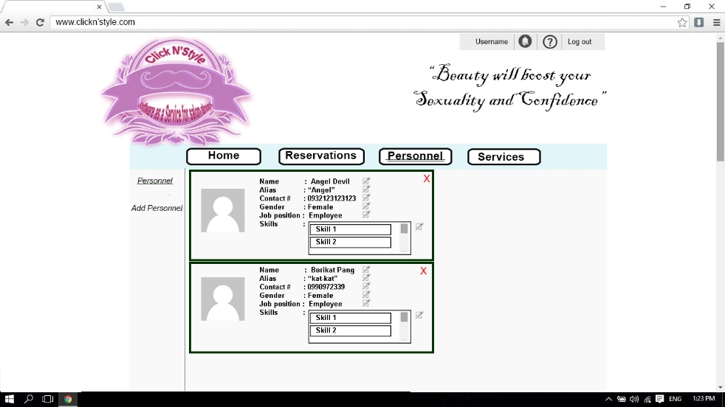

Figure 35: **Story Board: View Personnel**

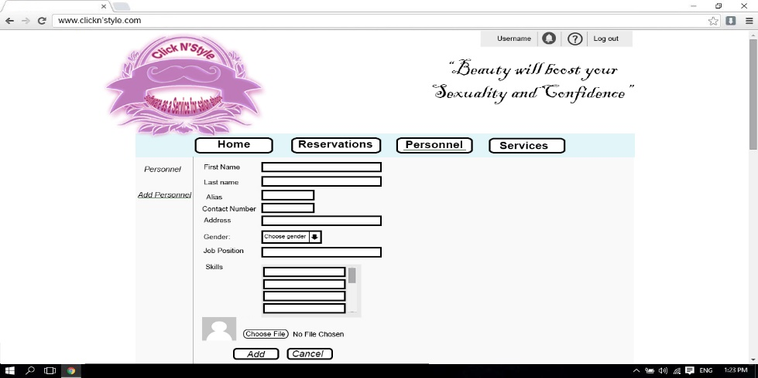Salonadmin can update the details of their personnel.

Figure 36: **Story Board: Add Personnel**

Salonadmin can add apersonnel

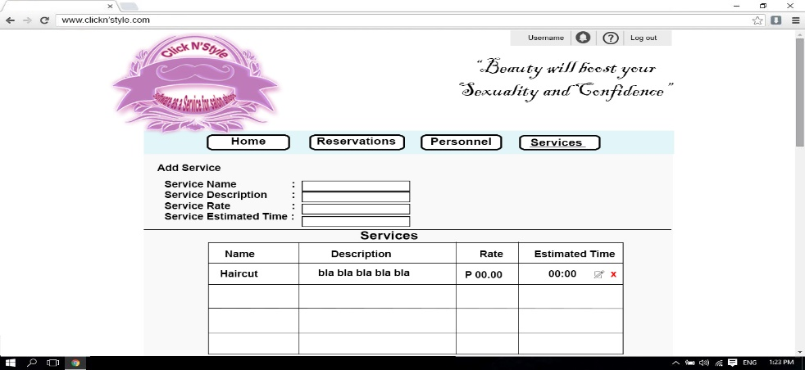

Figure 37: **Story Board: Services**

Salonadmin can add, update and delete their services

#### **Super Admin Story Board**

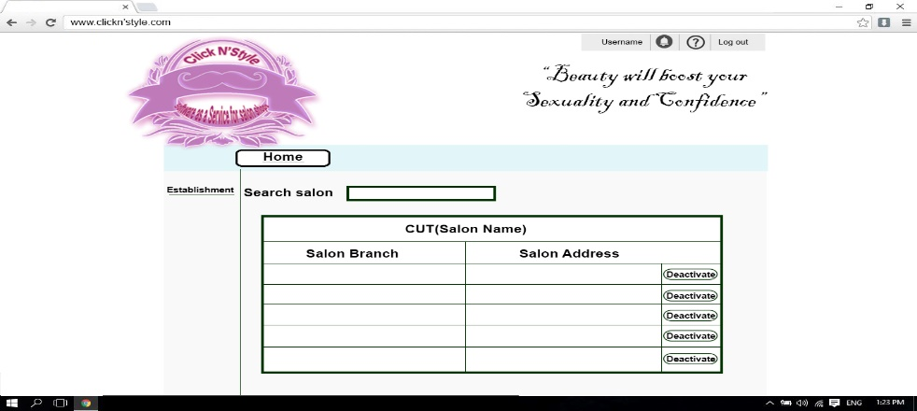

Figure 38: **Story Board: Establishment (Super Admin)**

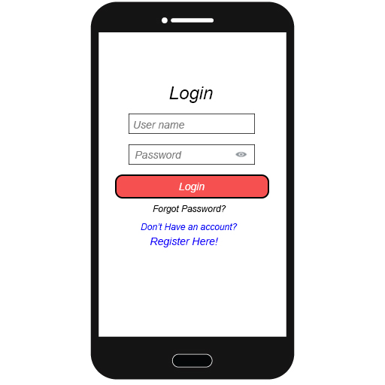The super admin can view all salons that subscribed in the system

Figure 39: **Story Board: Log in – Mobile**

Users can log-in in the mobile

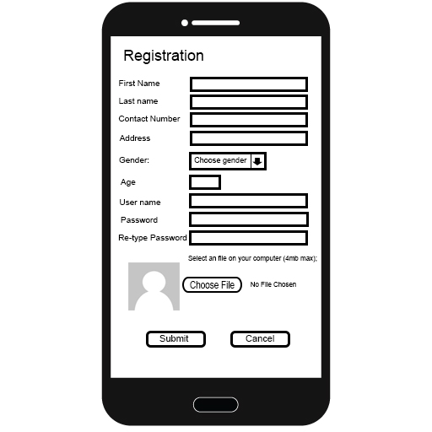

Figure 40: **Story Board: Registration - Mobile**

Users can also register in the mobile

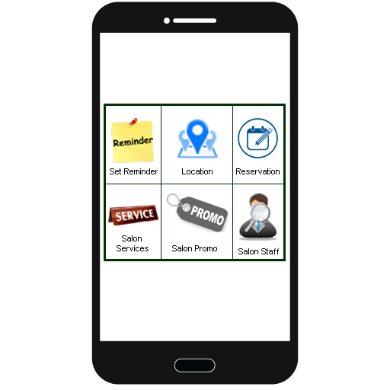

Figure 41: **Story Board: Home – Mobile**

The Home Interface of the user

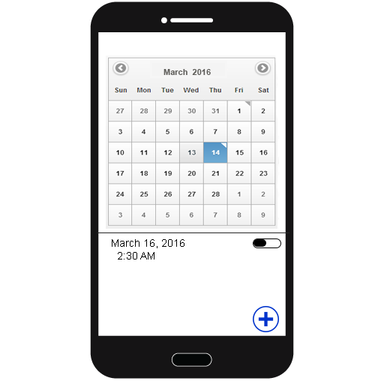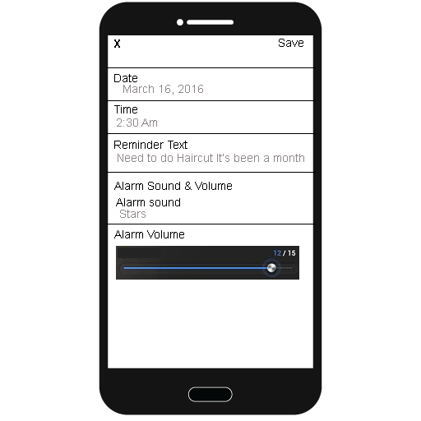

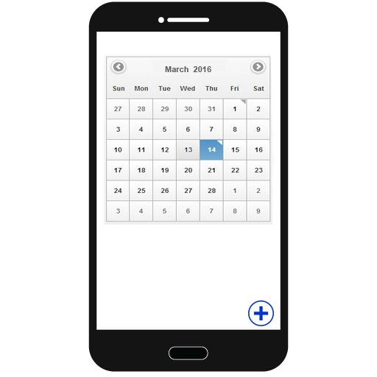

Figure 42: **Story Board: Reminder – Mobile**

User can set a reminder when was the last time the user went to a salon

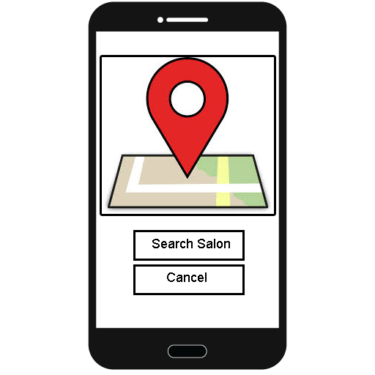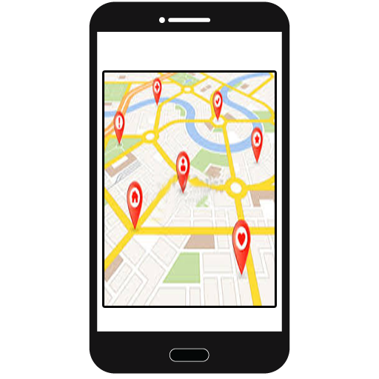

Figure 43: **Story Board: Location - Mobile**

User can search for a salon’slocation

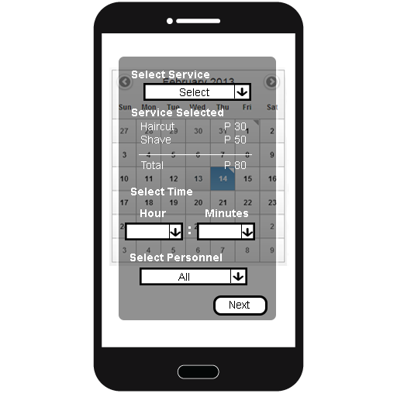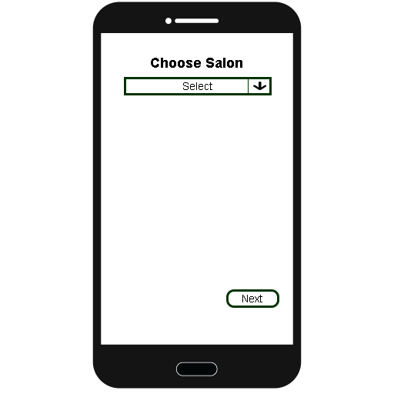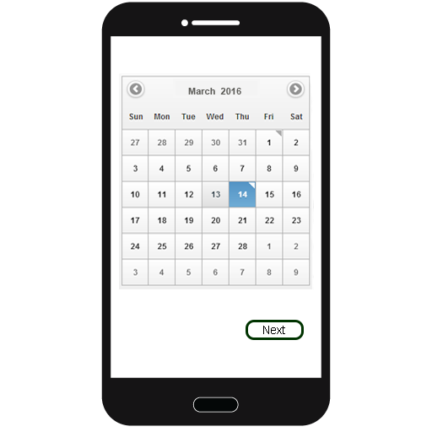

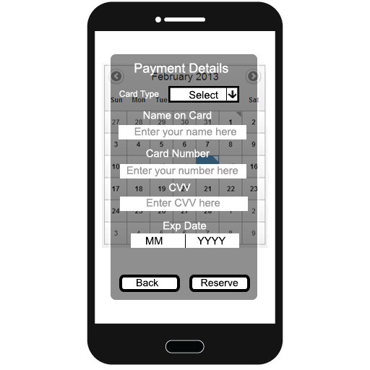

Figure 44: **Story Board: Reservation – Mobile**

The user can also make reservations through mobile

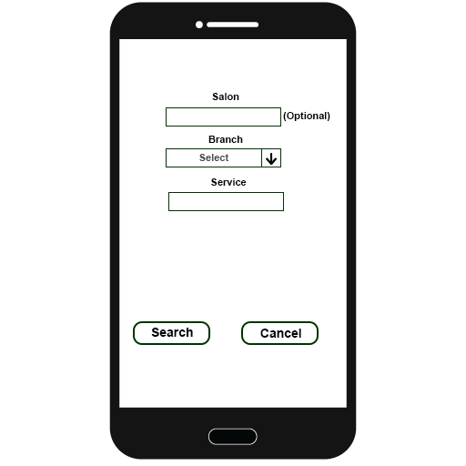

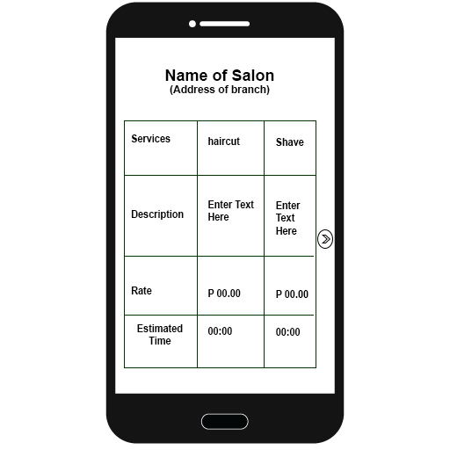

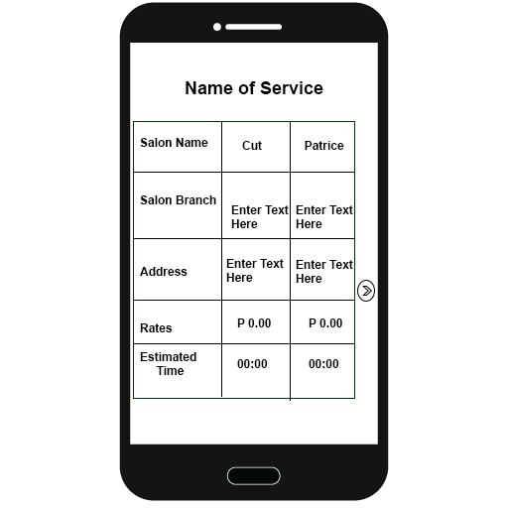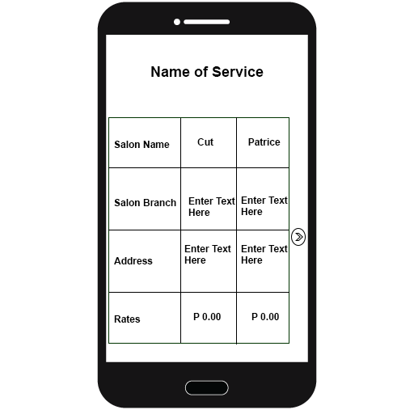

Figure 45: **Story Board: Services - Mobile**

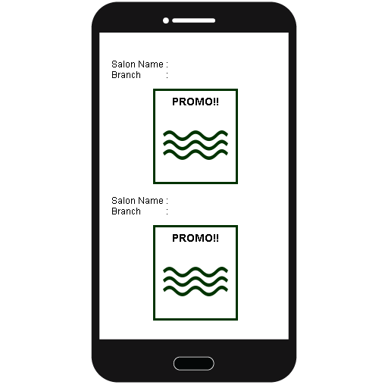The user can search which salons offer a particular service

Figure 46: **Story Board: Promos - Mobile**

User can view promos that the salon admin posted

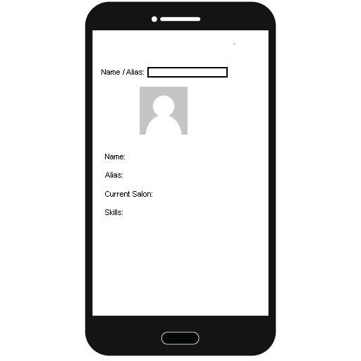

Figure 47: **Story Board: Search personnel – Mobile**

User can also search for a personnel in the mobile app

### **Entity Relationship Diagram**

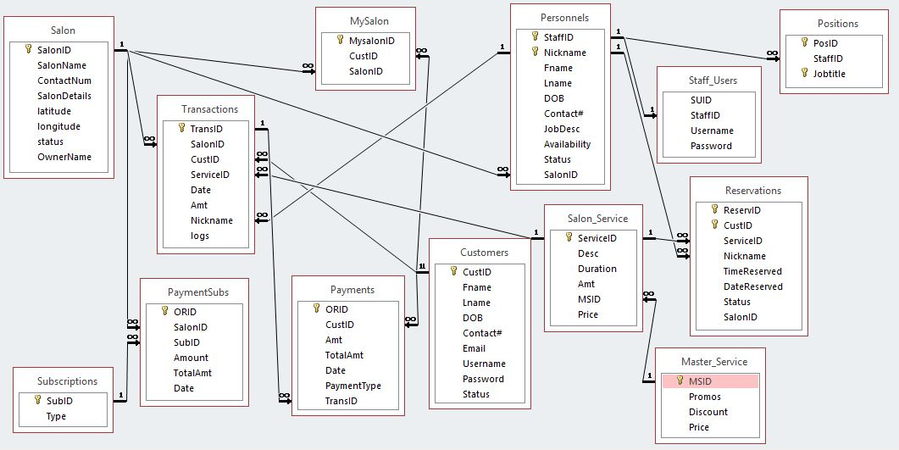

Figure 48: **Entity Relationship Diagram**

### **Data Dictionary**

Table 7

PAYMENTS

|  |  |  |  |  |
| --- | --- | --- | --- | --- |
| Field Name | Description | Data Type | Nullable | Domain |
| ORID | Primary Key, unique Payment record identifier | Int | No | Numeric |
| CustID | Foreign key from customers table | Int | No | Numeric |
| Amount | The amount paid of the customer | Decimal | No | Numeric |
| TotalAmt | The total amount that the customer paid |  |  |  |
| Date | The date that the user paid | Date | No | Alpha numeric |
| Payment Type | the type of payment | Vachar(20) | No | Alpha numeric |
| TransID | Foreign key from transaction table | Int | No | Numeric |

Table 8

SALONS

|  |  |  |  |  |
| --- | --- | --- | --- | --- |
| Field Name | Description | Data Type | Nullable | Domain |
| SalonID | Primary Key, unique salons record identifier | Int | No | numeric |
| SalonName | Name of a salon | Varchar(50) | No | Alpha  numeric |
| ContanctNo | The telephone number of the salon | Int | No | numeric |
| SalonDetails | Details with in the Salon | Varchar(1000) | No | Alpha numeric |
| Latitude | The latitude of the branch | Varchar(50) | No | Alpha  numeric |
| Longitude | The longitude of the branch | Varchar(50) | No | Alpha numeric |
| Status | The status of a Salon | Varchar(50) | No | Alpha numeric |
| OwnerName | The name of an owner | Varchar(20) | No | Alpha numeric |

Table 9

PAYMENTSUBS

|  |  |  |  |  |
| --- | --- | --- | --- | --- |
| Field Name | Description | Data Type | Nullable | Domain |
| ORID | Primary Key, unique PaymentSubs record identifier | Int | No | Numeric |
| SalonID | Foreign key from Salons table | Int | No | Alpha numeric |
| SubID | Foreign key from Subscription table | Int | No | Alpha numeric |
| Amount | The amount payment of the owner | Decimal | No | numeric |
| Date | The date that the owner paid | Date | No | Alpha numeric |

Table 10

SUBSCRIPTIONS

|  |  |  |  |  |
| --- | --- | --- | --- | --- |
| Field Name | Description | Data Type | Nullable | Domain |
| SubID | Primary Key, unique Subscriptions record identifier | Int | No | Numeric |
| Type | Type of subscription that the owner will accommodate | Varchar(100) | No | Alpha  numeric |

Table 11

STAFF_USERS

|  |  |  |  |  |
| --- | --- | --- | --- | --- |
| Field Name | Description | Data Type | Nullable | Domain |
| SUID | Primary Key, unique User record identifier | Int | No | Numeric |
| StaffID | Foreign key from Personnels table | Int | No | Numeric |
| Username | The Username that the owner will give to a certain personnel | Varchar(30) | No | Alpha numeric |
| Password | The password that the owner will give to a certain personnel | Varchar(20) | No | Alpha numeric |

Table 12

PROMOS

|  |  |  |  |  |
| --- | --- | --- | --- | --- |
| Field Name | Description | Data Type | Nullable | Domain |
| PromoID | Primary Key, unique promos record identifier | Int | No | Numeric |
| PromoDetails | Details of a Promo | Varchar(225) | No | Alpha numeric |
| DatePosted | The date posted by the salon admin | Date | No | Alpha Numeric |
| SalonID | Foreign key from salons table | Int | No | Numeric |
| ExpDate | The Expiry date of the promo | Date | No | Alpha numeric |

Table 13

TRANSACTIONS

|  |  |  |  |  |
| --- | --- | --- | --- | --- |
| Field Name | Description | Data Type | Nullable | Domain |
| TransID | Primary Key, transactions record identifier | Int | No | Numeric |
| SalonID | Foreign key from salons table | Int | No | numeric |
| CustID | Foreign key from customers table | Int | No | Numeric |
| ServiceID | Foreign key from services table | Int | No | Numeric |
| Date | The date when the user paid | Date | No | Alpha numeric |
| Amount | The amount that the customer paid | Decimal | No | numeric |
| Nickname | Foreign key from personnel table | Int | No | numeric |
| Logs | The logs from where the customer went to a salon | Varchar(100) | No | Alpha numeric |

Table 14

CUSTOMERS

|  |  |  |  |  |
| --- | --- | --- | --- | --- |
| Field Name | Description | Data Type | Nullable | Domain |
| CustID | Primary Key, Customers record identifier | Int | No | Numeric |
| Fname | The firstname of the customer | Varchar(50) | No | Alpha |
| Lname | The lastname of the customer | Varchar(50) | No | Alpha |
| DOB | Date of birth of the customer | Date | No | Alpha numeric |
| ContactNo | Cellphone number of the customer | int | No | numeric |
| Email | Email address of the customer | Varchar(70) | No | Alpha numeric |
| Username | User name of the customer | Varchar(50) | No | Alpha numeric |
| Password | Password of the customer | Varchar(50) | No | Alpha numeric |
| Status | The status of the customer if he or she is active or inactive | Varchar(30) | no | Alpha numeric |

Table 15

PERSONNELS

|  |  |  |  |  |
| --- | --- | --- | --- | --- |
| Field Name | Description | Data Type | Nullable | Domain |
| StaffID | Primary Key, Personnels record identifier | Int | No | Numeric |
| Nickname | Primary Key, Personnels record identifier | Varchar(20) | No | Alpha numeric |
| Lname | The lastname of the customer | Varchar(50) | No | Alpha |
| Fname | The firstname of the customer | Varchar(50) | No | Alpha |
| DOB | Date of birth of a personnel | date | No | Alpha numeric |
| ContactNo | Cellphone number of a personnel | int | No | numeric |
| JobDescription | The job description of the personnel | Varchar(100) | No | Alpha numeric |
| Availability | The time when the personnel is available | time | No | numeric |
| Status | If the personnel is still employed in the salon or not employed | Varchar(30) | no | Alpha numeric |
| SalonID | Foreign key from salons table | int | No | numeric |

Table 16

POSITIONS

|  |  |  |  |  |
| --- | --- | --- | --- | --- |
| Field Name | Description | Data Type | Nullable | Domain |
| PosID | Primary Key, positions record identifier | Int | No | Numeric |
| StaffID | Foreign key from personnel’s table | int | No | numeric |
| JobTitle | Primary key, positions record identifier | Varchar(50) | No | Alpha numeric |

Table 17

SALON_SERVICE

|  |  |  |  |  |
| --- | --- | --- | --- | --- |
| Field Name | Description | Data Type | Nullable | Domain |
| ServiceID | Primary Key, Services record identifier | Int | No | Numeric |
| Description | The description of a certain service | Varchar(100) | No | Alpha numeric |
| Duration | The estimated time of a service | Time | No | numeric |
| MSID | Foreign key from Master_Service table | Int | No | numeric |
| Price | Price of a certain service | Decimal | No | numeric |

Table 18

MASTER_SERVICE

|  |  |  |  |  |
| --- | --- | --- | --- | --- |
| Field Name | Description | Data Type | Nullable | Domain |
| MSID | Primary Key, Master_Service record identifier | Int | No | Numeric |
| Promos | The promos that the salon admin will post | Varchar(100) | No | Alpha numeric |
| Discount | Discount of a certain service | Decimal | No | numeric |
| Price | The price of a service | Decimal | No | numeric |

Table 19

RESERVATION

|  |  |  |  |  |
| --- | --- | --- | --- | --- |
| Field Name | Description | Data Type | Nullable | Domain |
| ReserveID | Primary Key, Reservation record identifier | Int | No | Numeric |
| CustID | Primary Key, Reservation record identifier | Int | No | numeric |
| ServicesID | Foreign key from Services table | Int | No | numeric |
| Nickname | Foreign key from personnel table | Varchar(20) | No | alpha |
| TimeReserved | The time that the customer reserved | Time | No | numeric |
| DateReserved | The date that the customer reserved | Date | No | Alpha numeric |
| Status | Status of a reservation | Varchar(50) | No | Alpha numeric |
| SalonID | Foreign key from salon table | Int | No | numeric |

### **Network Design**

Click N’Style will be using Transmission Control Protocol/Internet Protocol (TCP/IP) because it is considered to be reliable. The protocol itself checks between the users and the client is being transmitted at the receiving end and also the TCP/IP allows the retransmission of lost packets, therefore TCP/IP checks if all data transmitted is eventually received.

### **Network Model**

Click N’Style will be usingWide Area Network (WAN) because of its effectiveness in relaying data among Users and Clients from various geographical locations across Cebu. In the bottom line, this mode of telecommunication allows our system to effectively carry out its daily function regardless of location.

### **Network Topology**

The network topology of the system is shown in Figure 49, which is a Star Topology – one of the basic and most common network topologies. It consists of one central device called switch, router, hub or computer, which acts as a conduit to transmit message from salon admin to user.

The proponents chose this topology because of the advantages when developing the system. Star topology has centralized management, which is very helpful to us since our system is focused on the user experience. Failure of one node does not affect the rest of the network. At the same time, it’s easy to detect the failure and can be traced right away. The only disadvantage of this topology to our system is when the website is down, none of the users can really access it.

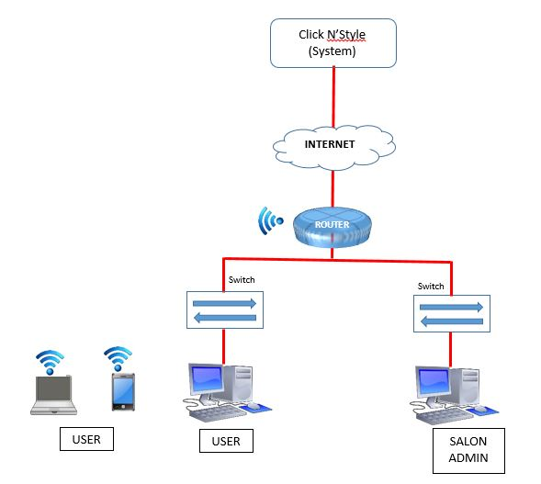

Figure 49:**Network Topology**

### **Technology Stack Diagram**

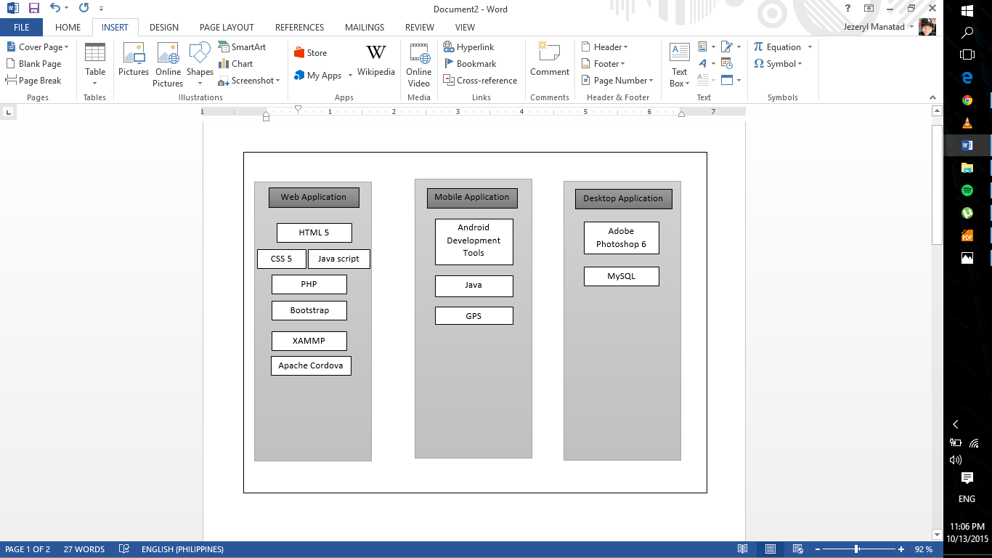

Figure 50: **Technology Stack Diagram**

### **Software Specification**

Table 20

SOFTWARESPECIFICATION

|  |  |  |
| --- | --- | --- |
|  | **Mobile** | **Web** |
| **Operating System** | Android OS versions from Android 4.0 (Ice-cream Sandwich) to latest | * Windows XP (any version) * Windows Vista * Windows 7(any version) Windows 8 |
| **Web Browsers** | * Opera * Google Chrome | * Internet Explorer 8 * Mozilla Firefox * Opera * Google Chrome |
| **Tools** | Eclipse | * Sublime 3 or notepad++ text editor * JQUERY * PHP * HTML * CSS * JavaScript * Bootstrap * Adobe Photoshop 6 * Database: MySQL |

### **Hardware Specification**

Table 21

HARDWARESPECIFICATION

|  |  |  |
| --- | --- | --- |
|  | **Mobile** | **Web** |
| Processor(CPU) | 830MHz Processor or higher | 1.0 GHz or higher + CPU |
| Hard Disk Drive (HDD) | 30MB or higher | 80GB or higher |
| Random Access Memory (RAM) | 512MB or higher | 1GB or higher |

### **Program Specification**

The system is a Software As A service for both desktop and hand-held devices such as mobile phones and laptops with a functional internet connection. The users can easily locate a salon. The system will be providing a list of all possible salons who will subscribe. The user can set a reservation in a salon that they chose. As for the clients, they can announce their promos in the web.

The program specifications enlisted below as a list of modules that the proponents must achieve to complete and attain the objectives of this project

### **List of Modules**

Table 22

LISTOFWEBMODULES

|  |  |  |  |  |  |
| --- | --- | --- | --- | --- | --- |
| WEB MODULES |  |  |  |  |  |
| PROGRAMMER | MODULES | ADMIN | SALON ADMIN | ESTABLISHMENT | ENTHUSIAST |
|  | 1. Subscribers Management |  |  |  |  |
|  | Add |  | * |  |  |
| Jezeryl Manatad | View | * |  |  |  |
|  | Search | * |  |  |  |
|  | Update |  |  |  |  |
|  | Delete |  |  |  |  |
| No. of Points(1 point per module per person) | | 1 |  |  |  |
| PROGRAMMER | MODULES | ADMIN | SALON ADMIN | ESTABLISHMENT | ENTHUSIAST |
|  | 1. Customer Account Management |  |  |  |  |
|  | Add |  | * |  | * |
| Mark Vincent Cuyos | View | * | * |  | * |
|  | Search | * |  |  |  |
|  | Update |  | * |  | * |
|  | Delete |  |  |  | * |
| No. of Points(1 point per module per person) | | 1 | 1 |  | 1 |
| PROGRAMMER | MODULES | ADMIN | SALON ADMIN | ESTABLISHMENT | ENTHUSIAST |
|  | 1. Staff Management |  |  |  |  |
|  | Add |  | * |  |  |
| Christine Glipa | View | * | * |  | * |
|  | Search | * | * |  |  |
|  | Update |  | * |  |  |
|  | Delete |  | * |  |  |
| No. of Points(1 point per module per person) | | 1 | 1 |  | 1 |
|  | MODULES | ADMIN | SALON ADMIN | ESTABLISHMENT | ENTHUSIAST |
|  | 1. Services Management |  |  |  |  |
|  | Add |  | * |  |  |
| Christine Glipa | View | * | * |  | * |
|  | Search | * | * |  | * |
|  | Update |  | * |  |  |
|  | Delete |  | * |  |  |
| No. of Points(1 point per module per person) | | 1 | 1 |  | 1 |
| PROGRAMMER | MODULES | ADMIN | SALON ADMIN | ESTABLISHMENT | ENTHUSIAST |
|  | 1. Promos Management |  |  |  |  |
|  | Add |  | * |  |  |
| Mark Vincent Cuyos | View | * | * |  | * |
|  | Search | * | * |  |  |
|  | Update |  | * |  |  |
|  | Delete |  | * |  |  |
| No. of Points(1 point per module per person) | | 1 | 1 |  | 1 |
| PROGRAMMER | MODULES | ADMIN | SALON ADMIN | ESTABLISHMENT | ENTHUSIAST |
|  | 1. Reservation Management |  |  |  |  |
|  | Add |  |  |  | * |
| Jezeryl Manatad | View |  | * |  |  |
|  | Search |  | * |  |  |
|  | Update |  | * |  | * |
|  | Delete |  |  |  |  |
| No. of Points(1 point per module per person) | |  | 1 |  | 1 |

Table 23

LISTOFWEBMODULESCONTINUATION

|  |  |  |  |  |  |
| --- | --- | --- | --- | --- | --- |
| PROGRAMMER | MODULES | ADMIN | SALON ADMIN | ESTABLISHMENT | ENTHUSIAST |
|  | 1. Customer Reservation Monitoring |  |  |  |  |
|  | Add |  |  |  |  |
| Mark Vincent Cuyos | View |  | * |  |  |
|  | Search |  |  |  |  |
|  | Update |  | * |  |  |
|  | Delete |  |  |  |  |
| No. of Points(1 point per module per person) | |  | 1 |  |  |
| PROGRAMMER | MODULES | ADMIN | SALON ADMIN | ESTABLISHMENT | ENTHUSIAST |
|  | 1. Payment Transaction |  |  |  |  |
|  | Add |  |  |  | * |
| Mark Vincent Cuyos | View |  | * |  | * |
|  | Search |  |  |  |  |
|  | Update |  | * |  |  |
|  | Delete |  |  |  |  |
| No. of Points(1 point per module per person) | |  | 1 |  | 1 |
| PROGRAMMER | MODULES | ADMIN | SALON ADMIN | ESTABLISHMENT | ENTHUSIAST |
|  | 1. Staff User Account Management |  |  |  |  |
|  | Add |  | * |  |  |
| Mark Vincent Cuyos | View |  | * |  |  |
|  | Search |  | * |  |  |
|  | Update |  | * |  |  |
|  | Delete |  | * |  |  |
| No. of Points(1 point per module per person) | |  | 1 |  | 1 |
| Number of Modules per User (equals total no. of points per user) | | 5 | 8 | 1 | 5 |
| Total Number of Modules | |  |  |  | 19 |

Table 24

LISTOFMOBILEMODULES

|  |  |  |  |  |  |
| --- | --- | --- | --- | --- | --- |
| MOBILE MODULES |  |  |  |  |  |
| PROGRAMMER | MODULES | ADMIN | SALON ADMIN | ESTABLISHMENT | ENTHUSIAST |
|  | 1. Account Management |  |  |  |  |
|  | Add |  |  |  | * |
| Mark Vincent Cuyos | View |  |  |  | * |
|  | Search |  |  |  |  |
|  | Update |  |  |  | * |
|  | Delete |  |  |  | * |
| No. of Points(1 point per module per person) | |  |  |  | 1 |
| PROGRAMMER | MODULES | ADMIN | SALON ADMIN | ESTABLISHMENT | ENTHUSIAST |
|  | 1. Staff Management |  |  |  |  |
|  | Add |  |  |  |  |
| Christine Glipa | View |  |  |  | * |
|  | Search |  |  |  | * |
|  | Update |  |  |  |  |
|  | Delete |  |  |  |  |
| No. of Points(1 point per module per person) | |  |  |  | 1 |
| PROGRAMMER | MODULES | ADMIN | SALON ADMIN | ESTABLISHMENT | ENTHUSIAST |
|  | 1. Services Management |  |  |  |  |
|  | Add |  |  |  |  |
| Christine Glipa | View |  |  |  | * |
|  | Search |  |  |  | * |
|  | Update |  |  |  |  |
|  | Delete |  |  |  |  |
| No. of Points(1 point per module per person) | |  |  |  | 1 |
| PROGRAMMER | MODULES | ADMIN | SALON ADMIN | ESTABLISHMENT | ENTHUSIAST |
|  | 1. Promos Management |  |  |  |  |
|  | Add |  |  |  |  |
| Mark Vincent Cuyos | View |  |  |  | * |
|  | Search |  |  |  |  |
|  | Update |  |  |  |  |
|  | Delete |  |  |  |  |
| No. of Points(1 point per module per person) | |  |  |  | 1 |
| PROGRAMMER | MODULES | ADMIN | SALON ADMIN | ESTABLISHMENT | ENTHUSIAST |
|  | 1. Reservation Management |  |  |  |  |
|  | Add |  |  |  | * |
| Jezeryl Manatad | View |  |  |  |  |
|  | Search |  |  |  |  |
|  | Update |  |  |  | * |
|  | Delete |  |  |  |  |
| No. of Points(1 point per module per person) | |  |  |  | 1 |
| Number of Modules per User (equals total no. of points per user) | |  |  |  |  |

Table 25

LISTOFMOBILEMODULESCONTINUATION

|  |  |  |  |  |  |
| --- | --- | --- | --- | --- | --- |
| PROGRAMMER | MODULES | ADMIN | SALON ADMIN | ESTABLISHMENT | ENTHUSIAST |
|  | 1. Payment Transaction |  |  |  |  |
|  | Add |  |  |  | * |
| Mark Vincent Cuyos | View |  |  |  | * |
|  | Search |  |  |  |  |
|  | Update |  |  |  |  |
|  | Delete |  |  |  |  |
| No. of Points(1 point per module per person) | |  |  |  | 1 |

Table 26

LISTOFMOBILEMODULESCONTINUATION

|  |  |  |  |  |  |
| --- | --- | --- | --- | --- | --- |
| PROGRAMMER | MODULES | ADMIN | SALON ADMIN | ESTABLISHMENT | ENTHUSIAST |
|  | 1. Location Management |  |  |  |  |
|  | Add |  |  |  |  |
| Mark Vincent Cuyos | View |  |  |  | * |
|  | Search |  |  |  | * |
|  | Update |  |  |  |  |
|  | Delete |  |  |  |  |
| No. of Points(1 point per module per person) | |  |  |  | 1 |
| PROGRAMMER | MODULES | ADMIN | SALON ADMIN | ESTABLISHMENT | ENTHUSIAST |
|  | 1. Reminder Management |  |  |  |  |
|  | Add |  |  |  | * |
| Mark Vincent Cuyos | View |  |  |  | * |
|  | Search |  |  |  |  |
|  | Update |  |  |  | * |
|  | Delete |  |  |  |  |
| No. of Points(1 point per module per person) | |  |  |  | 1 |
| Number of Modules per User (equals total no. of points per user) | |  |  |  | 8 |
| Total Number of Modules | |  |  |  | 8 |

# **References**

Anonymous. (2010).

CPprime. (2010). *Scrum .*

Lewis, J. (2003).

Pedia, T. (2011).

Prosser. (2015).

Roger. (2014). *Choose the best location for your hair salon and day spa.*

Whitten, B. &. (2004).

Wikipedia. (n.d.).

# **CURRICULUM VITAE**

**JEZERYL F. MANATAD**

*Unit 3 Oprra Kalunasan., Cebu City*

09339109696

[jezeryl10@gmail.com](mailto:jezeryl10@gmail.com)

**PERSONAL DETAILS**

• Date of Birth : April 3, 1995

• Gender : Male

• Civil Status : Single

• Nationality : Filipino

• Religion : Roman Catholic

• Language Spoken : English, Tagalog, Cebuano

**EDUCATIONAL BACKGROUND**

• College : University of Cebu – Main Campus

Bachelor of Science in Information Technology

2012 – Current

• High School : Abellana National School

Osmeña Blvd, Cebu City

S.Y: 2008– 2012

• Elementary : Lyceum of Cebu

Oprra Kalunasan, Cebu City

S.Y: 2002– 2007

**CHRISTINE T. GLIPA**

Upper Capaculan, Tisa Cebu City

268-7242 / 09324223075

[*christineyenglipa08@gmail.com*](mailto:christineyenglipa08@gmail.com)

**PERSONAL DETAILS**

• Date of Birth : February 19, 1995

• Gender : Female

• Civil Status : Single

• Nationality : Filipino

• Religion : Roman Catholic

• Language Spoken : English, Tagalog, Cebuano

**EDUCATIONAL BACKGROUND**

• College : University of Cebu – Main Campus

Bachelor of Science in Information Technology

2012 – Current

• High School : Tisa Integrated School

Fllamas St. Cebu City

S.Y: 2007– 2012

• Elementary : Tisa Integrated School

Fllamas St. Cebu City

S.Y: 2002– 2007

**MARK VINCENT C. CUYOS**

21 Rizal St. Ext. Mambaling, Cebu City

0943-509-9814

[mvcuyos@gmail.com](mailto:mvcuyos@gmail.com)

**PERSONAL DETAILS**

• Date of Birth : May 23, 1994

• Gender : Male

• Civil Status : Single

• Nationality : Filipino

• Religion : Roman Catholic

• Language Spoken : English, Tagalog, Cebuano

**EDUCATIONAL BACKGROUND**

Tertiary: University of Cebu – Main Campus

Sanciangko St. Cebu City

Bachelor of Science in Information Technology

S.Y: 2012– PRESENT

Secondary: Doña Liling National High School

Tapul, Tabogon, Cebu

S.Y: 2008– 2012

Elementary: Mambaling Elementary School

Cebu City

S.Y: 2000– 2006

# **Appendices**

## Appendix A: Oath of Confirmation Form







## Appendix B: Capstone Project Team Composition Form

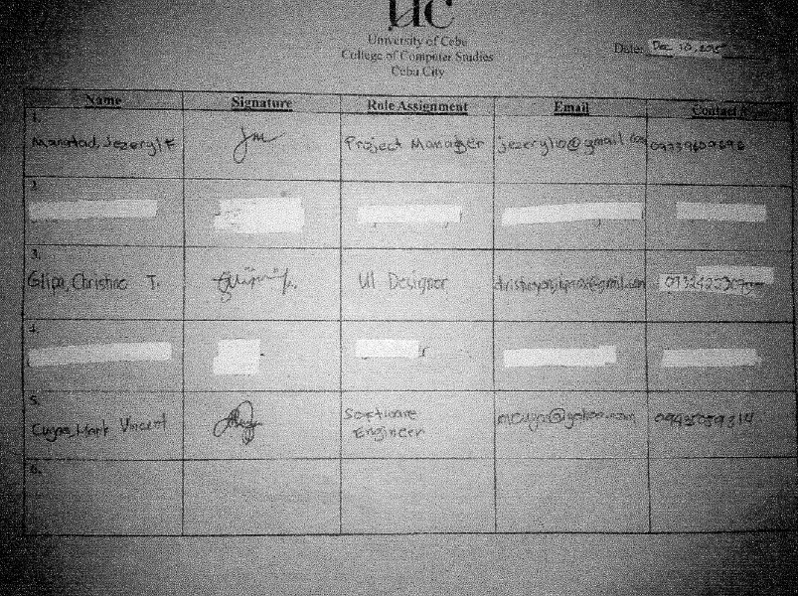

## Appendix E: Capstone Project Working Title Form



## Appendix G: Consultation Logs Form\\192.168.0.18\d\Jeze's Files\apendix\img022.jpg

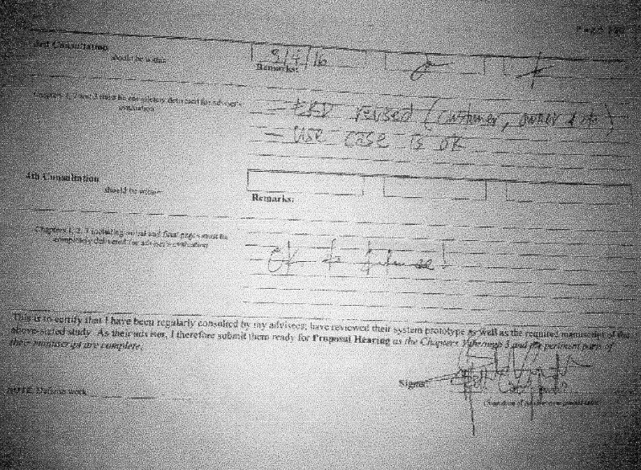

## Appendix H: Censor/ Technical Editor’s Certificate Form



## Appendix L: Capstone Project Hearing



## Appendix M: Capstone Project Panel Honoraria

